DAY 4 -> 14-05-2026
Project 1: Customer Churn Prediction & Lifetime Value (LTV) Engine
EDA -> Dataset Profiling & Data Understanding
DONE BY -> ANANTHARAJAN V B

DIFFERENT METHODS (continuation)
- Checking Hidden Blank Values in Object Columns
Description:
This method is used to identify hidden blank spaces present inside categorical or object-type columns. These blank spaces are not detected as normal missing values, so this step helps in identifying hidden data quality issues before preprocessing.
FORMULA USED
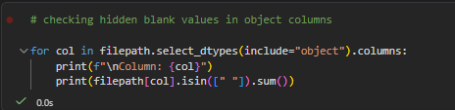
SCREENSHOTS
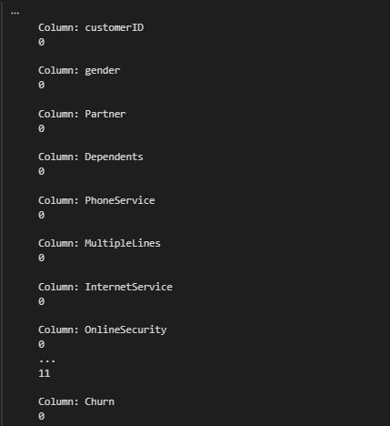

- Replacing Blank Spaces with NaN
Description:
This method is used to replace hidden blank spaces with proper null values (NaN). This ensures missing values are correctly recognized and can be handled during data cleaning and preprocessing.

FORMULA
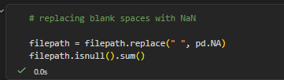
OUTPUT

SCREENSHOT
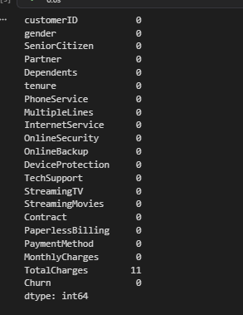

- DATATYPE INSPECTION
The filepath.dtypes function is used to inspect the datatype of each column in the dataset. It helps identify columns stored with incorrect datatypes, such as numerical columns mistakenly stored as object datatype.
FORMULA -> filepath.dtypes

SCREENSHOT
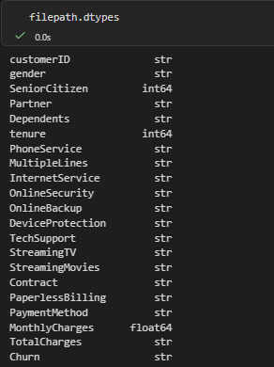

- Numerical Feature Statistics
The filepath.describe() function generates statistical summaries for numerical columns. It provides information such as count, mean, standard deviation, minimum value, maximum value, and quartiles to understand numerical data distribution.

FORMULA-> filepath.describe()

SCREENSHOT

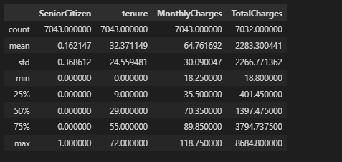

- Check Unique Values
Description:
The filepath.nunique() function calculates the total number of unique values in each column. It helps identify categorical columns, identifier columns, and columns with low or high cardinality.
FORMULA-> filepath.nunique()
SCREENSHOT
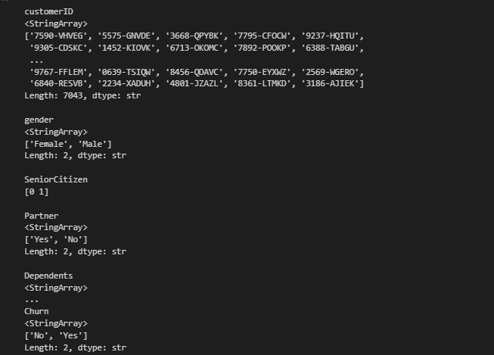

- Analyze Churn Distribution

Description:
These functions are used to analyze the distribution of churn categories in the dataset. The first function shows the total count of churned and non-churned customers, while the second calculates their percentage distribution to identify class imbalance.

FORMULA
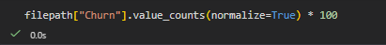

SCREENSHOT
